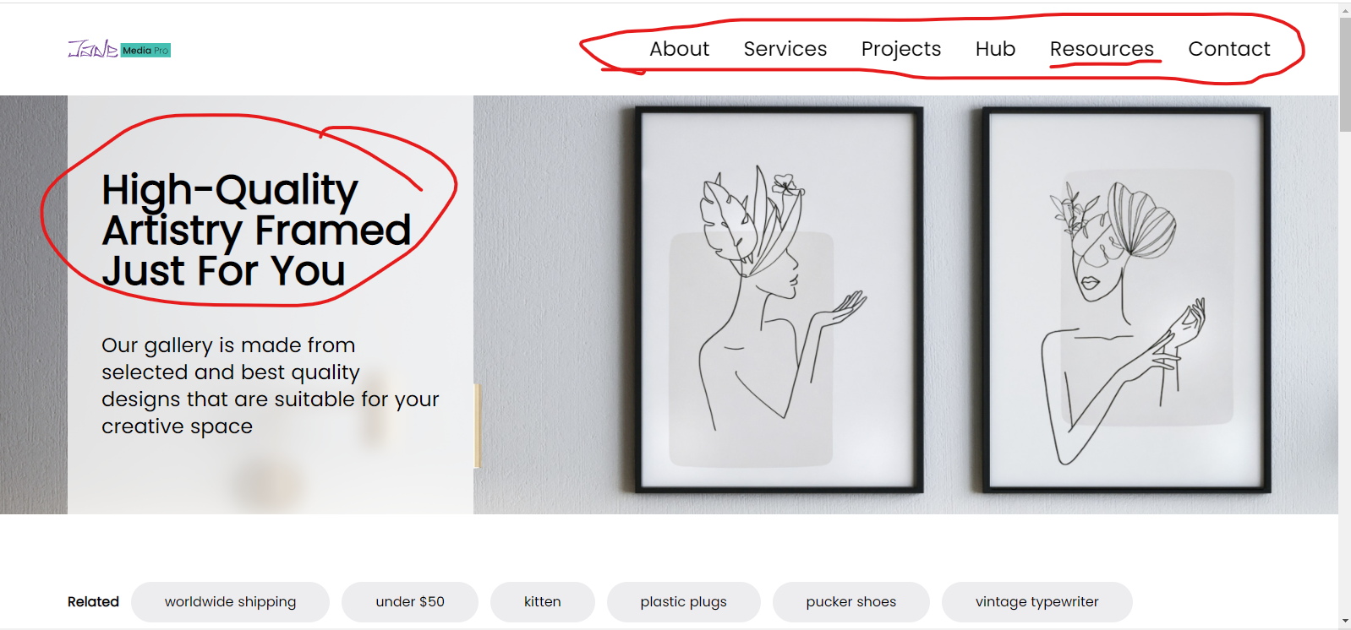

“Resources” bold effect and the line interaction.

All menu text sizes check.

The headline text height spacing and size is not looking like Figma.

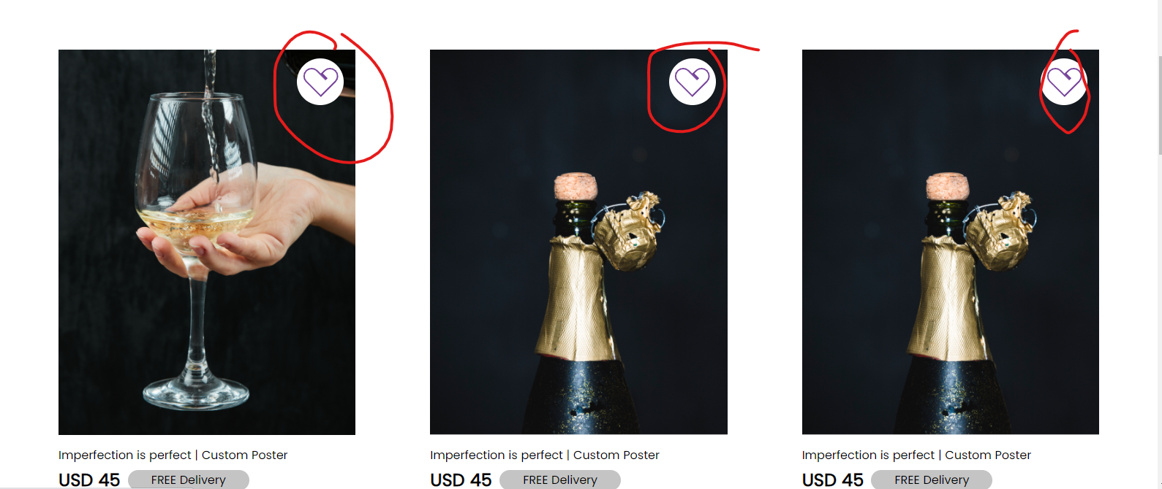

The like symbols should appear on hover.

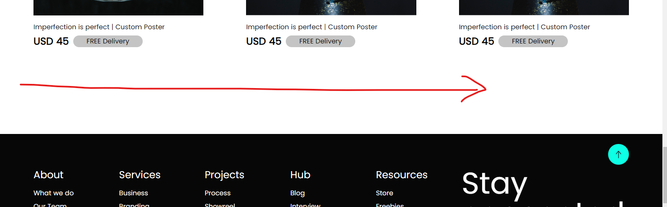

Next page navigator missing.